Literacy support worksheet

4.1 Synthesis and decomposition reactions can be represented by equations

Pages 90–91

Synthesis and decomposition reactions

1 Name the five ways we can classify compounds.

|  |
| --- |
|  |
|  |
|  |

2 Name the four ways we can classify reactions.

|  |
| --- |
|  |
|  |
|  |

3 There are many types of chemical reactions. Explain the following reactions.

a What is a synthesis reaction?

|  |
| --- |
|  |
|  |

b What is a decomposition reaction?

|  |
| --- |
|  |
|  |

c What is a hydrolysis reaction?

|  |
| --- |
|  |
|  |

4 Identify the following reactions as synthesis or decomposition.

a 2Na(s) + Cl2(g) → 2NaCl(l)

|  |
| --- |
|  |

b 2Mg(s) + O2(g) → 2MgO(s)

|  |
| --- |
|  |

c 2H2O(l) → 2H2(g) + O2(g)

|  |
| --- |
|  |

d 2HCl(aq) + Mg(s) → MgCl2(aq) + H2(g)

|  |
| --- |
|  |

Word detective – Fill in the blanks

5 Use the following word list to fill in the blanks in the sentences below. The sentences explain the steps for writing a chemical reaction.

Word list: chemical, same, atom, equation, aqueous, symbols, products, large

1 Write the \_\_\_\_\_\_\_\_\_\_\_\_\_\_\_\_\_\_\_\_\_ for the elements.

2 Write the \_\_\_\_\_\_\_\_\_\_\_\_\_\_\_\_\_\_\_\_\_ formula for each of the molecules. Use smaller subscript numbers to show the number of each \_\_\_\_\_\_\_\_\_\_\_\_\_\_\_\_\_\_\_\_\_ in the molecule.

3 Count the number of atoms on each side of the \_\_\_\_\_\_\_\_\_\_\_\_\_\_\_\_\_\_\_\_\_ to make sure there is the \_\_\_\_\_\_\_\_\_\_\_\_\_\_\_\_\_\_\_\_ number of atoms on both sides. If more atoms are needed, put a \_\_\_\_\_\_\_\_\_\_\_\_\_\_\_\_\_\_\_\_\_ number before the molecule.

4 Determine if the reactants and \_\_\_\_\_\_\_\_\_\_\_\_\_\_\_\_\_\_\_\_\_ are solids (s), liquids (l), gases

(g) or \_\_\_\_\_\_\_\_\_\_\_\_\_\_\_\_\_\_\_\_\_ solutions (aq) and write next to each molecule.

Literacy support worksheet

4.2 Acid reactions depend on strength and concentration

Pages 92–93

Acid reactions

1 What is an acid?

|  |
| --- |
|  |
|  |

2 Why are strong acids dangerous?

|  |
| --- |
|  |
|  |

3 Complete the following sentence:

‘All acids\_\_\_\_\_\_\_\_\_\_\_\_\_\_\_\_\_\_\_\_\_\_\_\_\_\_\_\_\_\_\_\_\_\_\_\_\_\_\_\_\_\_\_\_\_\_\_\_\_\_\_\_\_\_\_\_.’

4 What is a base?

|  |
| --- |
|  |
|  |

5 What do all bases have in common?

|  |
| --- |
|  |
|  |

6 Complete the table below on the properties of acids and bases.

|  |  |
| --- | --- |
| Properties of acids | Properties of bases |
| Tastes sour |  |
|  | Turns litmus paper blue |
|  |  |

7 What are the products of the following metal reactions?

a acid + base

|  |
| --- |
|  |

b acid + metal

|  |
| --- |
|  |

c acid + metal oxide

|  |
| --- |
|  |

d acid + metal carbonate

|  |
| --- |
|  |

8 Identify the following images as either a dilute strong acid, a concentrated strong acid, a dilute weak acid, or a concentrated weak acid.

|  |  |  |  |
| --- | --- | --- | --- |
| L:\1. Publishing and Editorial\1. Product\Oxford Science\Oxford Science 10\3. Extras\6. Student worksheets\Artwork\4. Final jpgs\SW0401_01095.jpg | L:\1. Publishing and Editorial\1. Product\Oxford Science\Oxford Science 10\3. Extras\6. Student worksheets\Artwork\4. Final jpgs\SW0402_01095.jpg | L:\1. Publishing and Editorial\1. Product\Oxford Science\Oxford Science 10\3. Extras\6. Student worksheets\Artwork\4. Final jpgs\SW0403_01095.jpg | L:\1. Publishing and Editorial\1. Product\Oxford Science\Oxford Science 10\3. Extras\6. Student worksheets\Artwork\4. Final jpgs\SW0404_01095.jpg |
|  |  |  |  |

Word detective – Match the words

9 Draw a line between each image and its correct description using the information below.

A strong acid donates a hydrogen ion (H+) to a base to form a molecule such as HCl.

A concentrated acid has more molecules and less water.

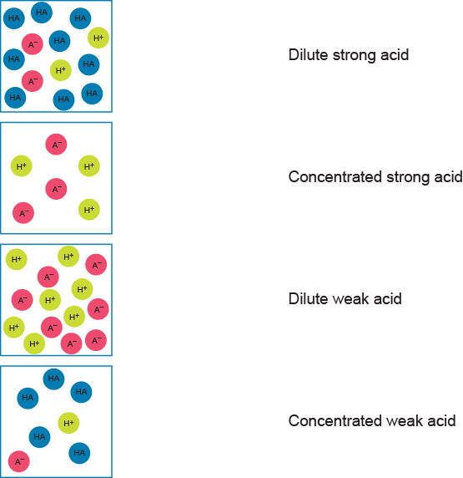

Literacy support worksheet

4.3 The solubility rules predict the formation of precipitates

Pages 94–95

Precipitation reactions

1 Complete the following sentence:

‘If a compound is soluble \_\_\_\_\_\_\_\_\_\_\_\_\_\_\_\_\_\_\_\_\_\_\_\_\_\_\_\_\_\_\_\_\_\_\_.’

2 What does it mean if something is insoluble?

|  |
| --- |
|  |
|  |

3 For each of the following molecules, determine whether it is soluble or insoluble. The first one has been done for you.

a AgNO3: soluble (aq)

b NH4Cl:

|  |
| --- |
|  |

c PbCl2:

|  |
| --- |
|  |

d Cu(OH)2:

|  |
| --- |
|  |

e Fe(OH)3:

|  |
| --- |
|  |

f NaNO3:

|  |
| --- |
|  |

4 For the following precipitation reactions, write a balanced chemical equation including states. The first one has been done for you.

a Pb2NO3 + NaCl →

|  |
| --- |
|  |

b Na2CO3 + MgCl2 →

|  |
| --- |
|  |

c 2NaOH + MgBr2 →

|  |
| --- |
|  |

Word detective – Draw and label

5 Draw and label what happens at the particle level when the ion partners are swapped in the equation below.

For example: Pb2NO3 + NaCl → PbCl2(s) + NaNO3(aq)

When a solution of lead (II) is added to sodium chloride. Use the equation:

AB(aq) + CD(aq) → AD(s) + CB(aq)

(Hint: Use the image below to help you.)

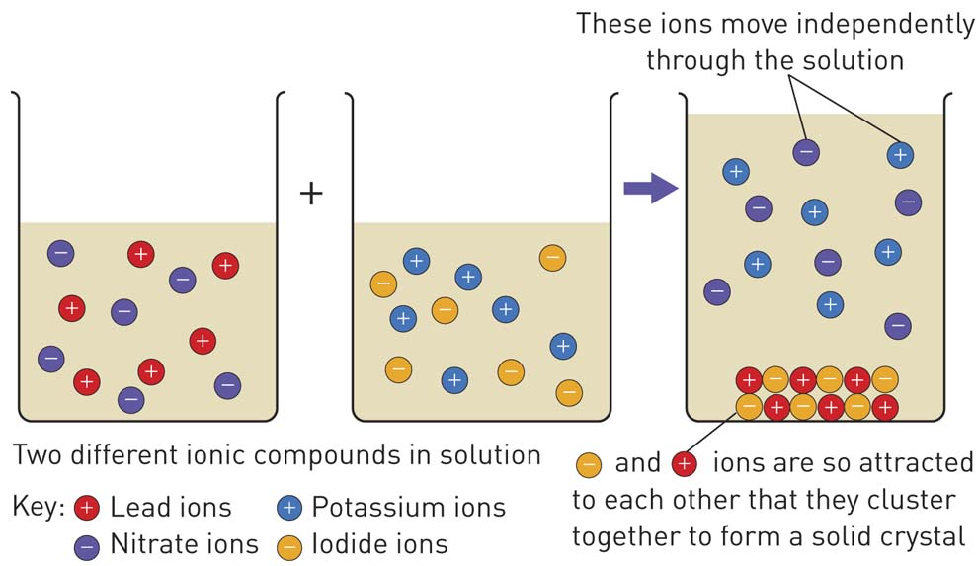

|  |
| --- |
|  |

Literacy support worksheet

4.4 Combustion reactions between hydrocarbons and oxygen produce carbon dioxide, water and energy

Pages 96–97

Combustion reactions

1 What is an oxidation reaction?

|  |
| --- |
|  |

2 What is a combustion reaction?

|  |
| --- |
|  |
|  |

3 What do combustion reactions between non-metals and oxygen produce?

|  |
| --- |
|  |

4 What do combustion reactions between the following produce?

a Non-metals + oxygen →

|  |
| --- |
|  |

b Hydrocarbon + oxygen →

|  |
| --- |
|  |

5 Fill in the blanks in the equations below.

a Metal + oxygen → \_\_\_\_\_\_\_\_\_\_\_\_\_\_\_\_\_\_\_\_

b Hydrocarbon + water → \_\_\_\_\_\_\_\_\_\_\_\_\_\_\_\_\_\_\_\_

c Hydrocarbon + limited water → \_\_\_\_\_\_\_\_\_\_\_\_\_\_\_\_\_\_\_\_

d Hydrocarbon + even less water → \_\_\_\_\_\_\_\_\_\_\_\_\_\_\_\_\_\_\_\_

6 Complete the following reactions, using the examples given to help you.

Oxidation reaction with metals:

Example 1: 2Mg(s) + O2(g) → 2MgO2

4Na(s) + O2(g) → 2Na2O(s)

|  |
| --- |
|  |

Oxidation reaction with non-metals:

Example 2: H2(g) + O(g) → 2H2O

S(g) + O2(g) → SO2(g)

|  |
| --- |
|  |

7 Write a balanced chemical equation for the combustion of the following hydrocarbons, remembering that carbon dioxide and water are always produced. The first one has been done for you.

Methane: CH4 + 2O2 → CO2 + 2H2O

Ethane: 2C2H6 + 7O2 →

|  |
| --- |
|  |

Propane: C3H8 + 5O2 →

|  |
| --- |
|  |

Butane: 2C4H10 + 13O2 →

|  |
| --- |
|  |

Pentane: C5H12 + 8O2 →

|  |
| --- |
|  |

Hexane: 2C6H14 + 19O2 →

|  |
| --- |
|  |

Heptane: C7H16 + 11O2 →

|  |
| --- |
|  |

Octane: 2C8H18 + 25O2 →

|  |
| --- |
|  |

Word detective – True or false

8 Read the statement and circle whether it is true or false.

a Oxidation reactions with metals are combustion reactions. T or F

b The most common fuels we use for combustion are hydrocarbons. T or F

c When pure hydrocarbons burn in oxygen, then produce carbon dioxide and water. T or F

d Diesel is mostly made up of octane. T or F

e When metals react with oxygen, a hydrocarbon is formed. T or F

f Group 17 non-metals do not react with oxygen. T or F

g Combustion reactions require oxygen. T or F

h Burnt hydrocarbons produce soot. T or F

Literacy support worksheet

4.5 Polymers are long chains of monomers

Pages 98–99

Polymers and polymerisation reactions

1 What is a monomer?

|  |
| --- |
|  |
|  |

2 What is a polymer?

|  |
| --- |
|  |
|  |

3 What is the process of forming a long chain polymer from smaller polymer molecules known as?

|  |
| --- |
|  |

4 Connect the word to its correct definition.

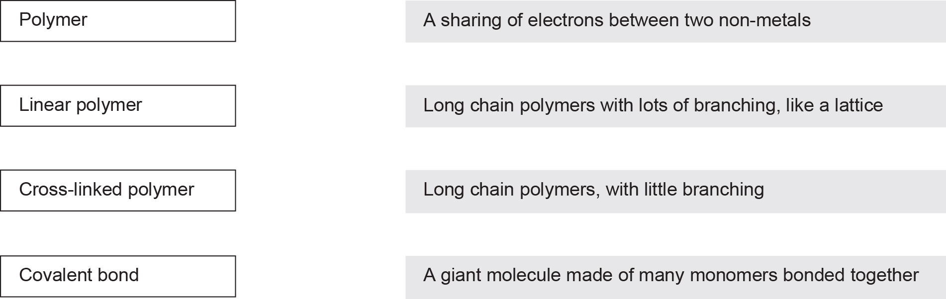

5 Identify the following structures as linear or cross-linked polymers.

|  |  |
| --- | --- |
|  |  |
|  |  |
|  |  |
|  |  |

6 Nylon is a synthetic polymer. Name two items nylon is used in.

|  |
| --- |
|  |
|  |

7 Polymers are made up of groups of monomers. Draw the polymers that would result from the following monomers. The first one has been done for you.

|  |  |
| --- | --- |
| Monomer | Polymer |
|  |  |
|  |  |
|  |  |

Word detective – Sequencing

8 Number the steps of the polymerisation process from 1 to 4 in the order they should appear.

\_\_\_\_\_\_\_ A polymer is formed.

\_\_\_\_\_\_\_ Giant molecules form that contain thousands of atoms.

\_\_\_\_\_\_\_ Small molecules are reacted under specific conditions.

\_\_\_\_\_\_\_ The molecules join together in a chain reaction.

Literacy support worksheet

4.6 Temperature, concentration, surface area and stirring affect reaction rate

Pages 100–103

Factors affecting the rate of a chemical reaction

1 Fill in the blank in the sentence below.

Collision theory is a theory that states the particles involved in a chemical reaction must \_\_\_\_\_\_\_\_\_\_\_\_\_\_\_\_\_\_\_\_\_\_\_\_\_\_\_\_\_\_\_ in order to react.

2 What are the two requirements of collision theory that allow reactants to form products?

|  |
| --- |
|  |
|  |

3 What three things need to be increased to increase the rate of reactions?

|  |
| --- |
|  |
|  |
|  |
|  |

4 In each of the following situations, circle the correct explanation.

a A mug of hot water and a mug of cold water dissolve a teaspoon of coffee.

i The mug of hot water will dissolve the coffee faster, due to the increased temperature and greater kinetic energy.

ii The cold water will dissolve the coffee faster because the lower temperature will cause the particles to move or shiver with cold.

b A whole cube of sugar and a teaspoon of granulated sugar dissolve in a cup of room-temperature water

i The whole cube of sugar will dissolve more quickly because it is larger so it has a larger surface.

ii Granulated sugar will dissolve faster as it has a greater surface area. This means there is more reactant to collide with and there will be more collisions.

c Two teabags are placed in two cups of hot water. One is stirred, one is not.

i The stirred tea will dissolve faster as particles have more kinetic energy. This makes particles move faster and therefore have more successful collisions.

ii The unstirred tea will dissolve faster because the particles are slower in the water. This means the tea particles can move faster and have more collisions.

Word detective – Draw and explain

5 Draw one of the scenarios from Question 4 and explain what is happening in your own words.

|  |  |
| --- | --- |
| Draw | Explain in your own words |
|  |  |

Literacy support worksheet

4.7 Catalysts increase the rate of a reaction

Pages 104–105

The effect of catalysts on the rate of a chemical reaction

What can increase the rate of a reaction?

|  |
| --- |
|  |

2 What does the ozone layer do?

|  |
| --- |
|  |
|  |

3 Name two problems that ultraviolet light can cause.

|  |
| --- |
|  |
|  |

4 What agreement was made in the Montreal Protocol in 1987?

|  |
| --- |
|  |
|  |

5 Why was this decision a positive one?

|  |
| --- |
|  |
|  |

6 Draw the structure that most catalysts are used in to increase the surfaced area. (Hint: Use Figure

4.24 in the student book to help you.)

|  |
| --- |
|  |

Word detective – Fill in the flow diagram

7 Fill in the blanks in the flow diagram below, describing how a solid catalyst works.

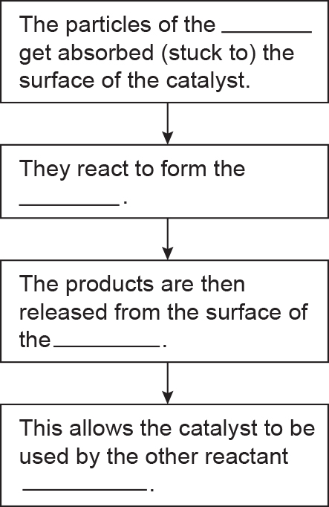

Literacy support worksheet

4.8 Green chemistry reduces the impact of chemicals on the environment

Pages 106–107

Green chemistry

1 Fill in the blanks in the sentence below.

Scientists detect changes caused by \_\_\_\_\_\_\_\_\_\_\_\_\_\_\_\_\_\_\_\_\_\_\_ events as well as by human

\_\_\_\_\_\_\_\_\_\_\_\_\_\_\_\_\_\_\_\_\_\_\_\_\_\_\_.

2 Many pesticides and herbicides used to kill organisms were non-biodegradable in the past. What does non-biodegradable mean?

|  |
| --- |
|  |

3 How did heavy metals cause harm in the past?

|  |
| --- |
|  |
|  |

4 Solvent-based paints were toxic to waterways and the fumes caused illness in workers. What was the illness developed by workers called?

|  |
| --- |
|  |

5 What is ‘green chemistry’ sometimes called?

|  |
| --- |
|  |

6 Suggest a more environmentally-friendly option for each of the items below.

a Using plastic bags

|  |
| --- |
|  |

b Driving a car to school or work

|  |
| --- |
|  |

c Protecting crops with pesticides

|  |
| --- |
|  |

Word detective – Design a poster

7 Design a poster in the space below that promotes Green Chemistry to the public. Ensure that you add some of the information from the previous question.